***Direct control of Single & Double acting Cylinder***

***Objective:***

To study and control single and double acting cylinder using push buttons

***Equipment’s and parts:***

* Single acting cylinder
* Double acting cylinder
* Connecting Pipes
* Mechanical push button
* Fluid (Air) Reservoir
* Regulator
* Air distributer (Multi dia pipes Junction)

***Working Explanation:***

The compressed air goes to switches that are mechanically operated and then goes to cylinder that are single acting as well as double acting causes to move the piston from its previous position to new position.

***Circuit Diagram***

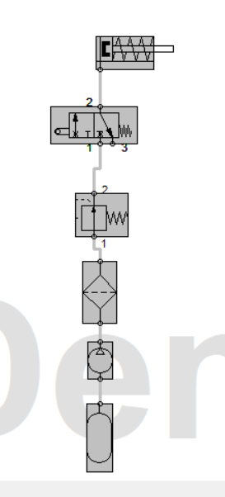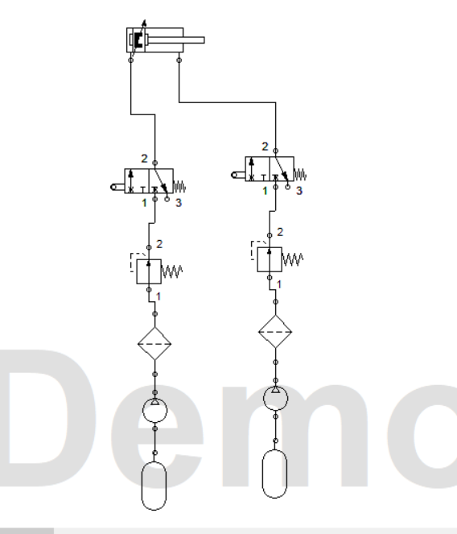

Single acting Cylinder Double acting Cylinder

***Conclusion:***

We learned the basic principle of single and double acting cylinder and their interfacing with push buttons. We also operated the single and double acting cylinder in real life using the hydraulic and pneumatic training bench